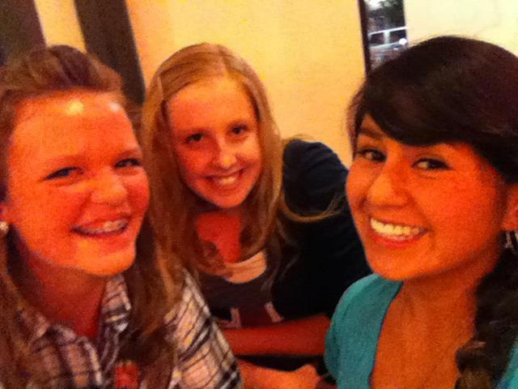
The Three Musketeers(picture of me)
Six years ago I met these two remarkable girls. We have had so many memories that will never ever be forgotten. Oakleigh, Olivia and I have had our ups and downs but what friendship doesn’t. That’s why I not only love to call them my best friends but my sisters.
This picture was taken Aug 10, 2012 or the last day we have hung out before we all separated to different schools. I miss laughing, talking and smiling with them every day, so that day was a great one. We were giggling in this photograph while watching the sight of ten teenage girls shoving their faces in creamy whipped cream to find ten colorful gummy bears. It was such an interesting game we played, but I mean what else do you do at your best friend’s birthday party? We were just in her dim unfinished basement with a smell fresh wood. Everyone was chanting and cheering at the girls to find the bears quickly while music played in the background.
Meanwhile the three musketeers (as we called ourselves) sat on a banded comfy cotton bed talking pictures to capture the moment forever. It’s sad to know we can’t have all those laughs together every day like the good old times but I’m glad I still get to have them as my best friends. I lived in that moment the best I could because I knew it would be a while before we could have many mores memories like that again. Let me tell you, that definitely was one great moment to live in and enjoy.

