Land use/Land cover change
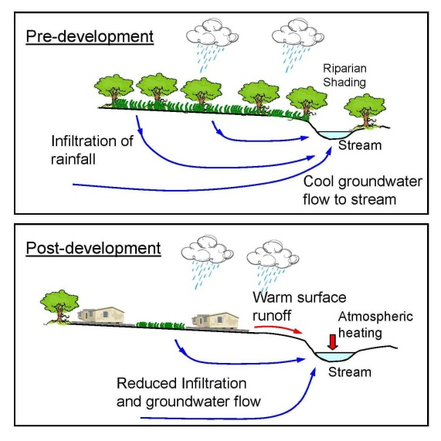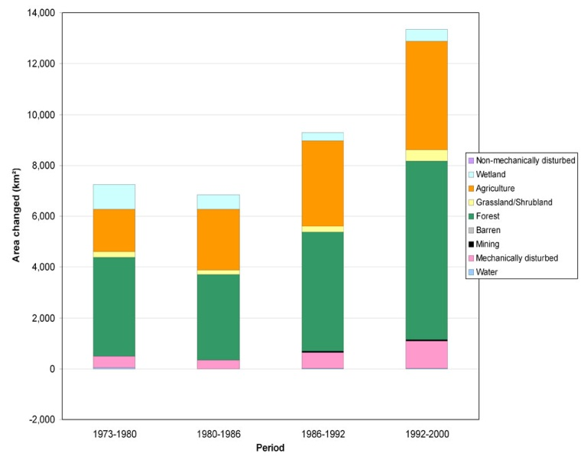

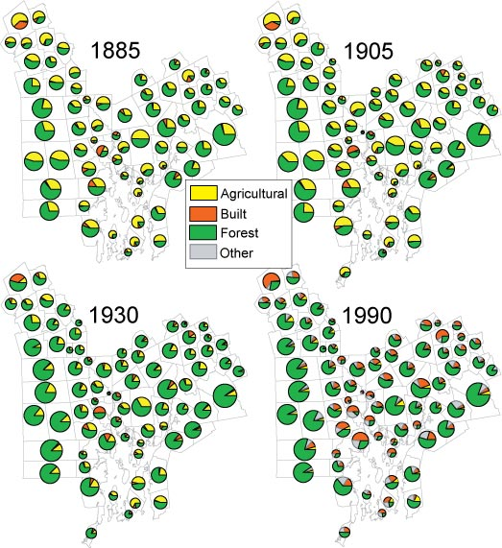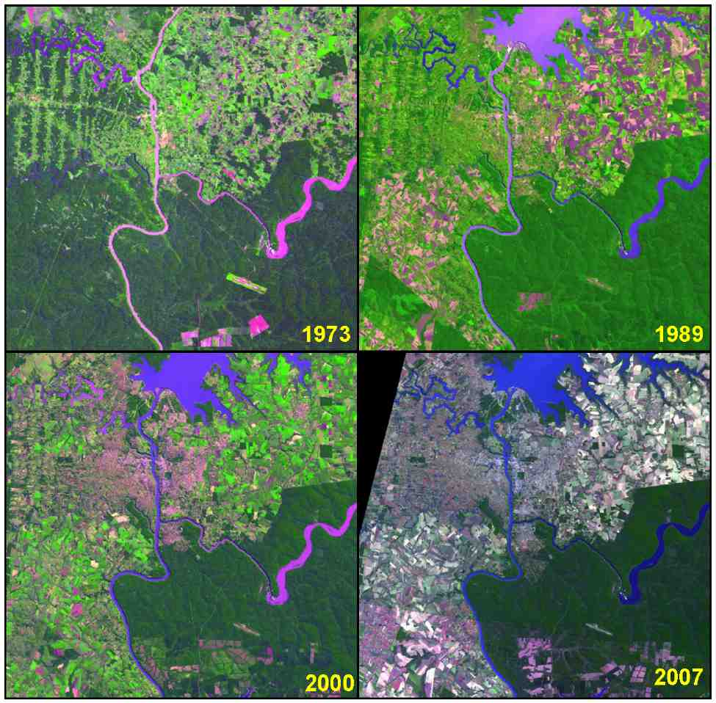

- *Land Use- Human uses of land
- Since the physical surface of the earth is in constant change the abundant water resources also give new growth, cities expand and forest is converted to farmland.
- Humans are a cause of the land change but the other is just changing of the seasons.
- Land use and land cover change has aroused increasing attention of scientist worldwide since 1990.
- Also
- Land use and land cover change are analyzed with remote sensing.
- Major effect of land use has been deforestation of temperate regions especially in 1750.
- Urban growth boundary is one form of land use regulations.
- Land use practices have a big impact on natural resources like: water, soil, nutrients, plants and animals.
- It can be used to develop solutions for resource management issues like salty and water quality.
- The use of satellite imagery has made the mapping of land cover much more practical.
- Satellite images are not photographs but they are taken form manned spacecraft such as a space shuttle.

